National University of Computer and Emerging Sciences


Lab Manual 09
Object Oriented Programming – CL1004

Course Instructor | Ms. Tayyba Bukhari
Lab Instructor(s) | Ms. Samman Ashraf  Ms. Zehra Batool
Section | BCS-9B
Semester | Summer 2023

Department of Computer Science FAST-NU, Lahore, Pakistan

Important Note:
- You may find the syntax to accomplish these exercises from lecture demo.
- Add Necessary Comments in you code to justify your logic.
- Comment exercise number or statement at the start of your code
- Save each exercise in .cpp file with your roll no, ex and lab number e.g.
- 22LXXXX_EX01_Lab01.cpp
- Place all of your exercises in a folder a Zip it (Do not create .rar file) with roll no and lab no. e.g. 22LXXX_Lab01.zip
- Make sure that the interface of your program is user friendly i.e. properly display information.

TASK1:
Exercise 1:

Lab Manual-09 Inheritance

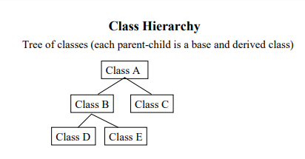
The Hierarchy between a parent and child classes looks like the following, where Class A is the parent of Class B and Class C. While Class B is the parent of Class D and Class E

Consider the following hierarchy as it exists in a university as draw its diagram as above:
- There are two types of persons in the university i.e. Student and Faculty
- Every Person has some basic information that is common to all persons i.e. the first_name and
last_name stored as private attributes and age which is a protected attribute.
- A student can in turn be either an Undergraduate or a Graduate student, every student has a

cgpa.
- An undergraduate student has a fyp_name as his private attribute.
- A graduate student has a thesis topic as his private attribute.
- A faculty member has private attributes about the number of courses he is currently teaching, i.e. his course_count and a three digit telephone extension number i.e. txt_ext.

Use the following template and copy paste the box for each class to complete the diagram here :

Class Name

Exercise 2:
Implement the entire hierarchy that you created in Exercise 1. Every class should be defined in a separate header file named according to the class name.
- Define all the classes along with their attributes and their inheritance.
- Add getters and setters for each attribute
- Add appropriate constructors and destructors to all the classes. For example the constructor for the Person class should take three inputs (for first_name, last_name and age). The student
constructor should take four inputs, three for its parent class (i.e. Person) and one float value to be assigned to the cgpa attribute.

This is accomplished in the following manner:

Person (char* fname, char* lname, int age)
{
...
cout << ”Person() called”;
}

Student (char* fname,char* lname,int age,float cgpa): Person(fname,lname,age)
{
...
cout << ”Student() called”;
}

This syntax can be generalized to any parent and child constructor accordingly. Following this syntax, define and implement constructors and destructors for all the classes. Also, Notice that you have to add a print statement in every constructor which announces that the constructor has been called.

Also add a print statement to every destructor which announces that the destructor has been called. For example, the destructor for Person should look like:

~Person()
{
cout << ”~Person() called”;
}

Exercise 3:
Create a C++ source file called 22Lxxxx_Inheritance.cpp. This file contains the main() function. In this main function create an undergraduate student “Muhammad” with cgpa 3.91 who is 22 years of age and a faculty member “Hammad” who is 45 years of age and who is teaching 2 courses this semester and his
extension number is 420. Build and execute the code.

Exercise 4:
You should notice that the age attribute in a Person is protected, while the first_name and last_name
attributes are private. What could be the reason for this? Write the reason below:
Reason:

Now Add a member function void printInformation() in the Person class. This method should print the name and age of the person.
Sample output:
Muhammad is 22 years old

Add a member function void printStudent() in the Student class. This method should print the name, cgpa and age of the student. Sample output: “Muhammad is 22 years old, his cgpa is 3.91”

First Use the following Implementation:

void Student::printStudent()
{

cout << first_name << ” ” << last_name
<< ”is ” << age <<” years old, his cgpa is ” << cgpa;
}

Now call the above printStudent() function for the student created in main(). Build the code, you will get an error. Paste the error in the following box.
Error:

Why did you get this error?
Reason:

Exercise 5:
Now change the implementation of the printStudent() function in order to remove the error, but you must still print the required output. Can you use a member function of the base class inside this function? Try that!

Also add a member function void printFaculty() in the Faculty class. This function should print the name, age, number of courses and extension number of the faculty member.

Sample output:
Faculty Member name: Hammad, Age: 45, Number of courses: 2, Ext. 420

Call the printStudent() and printFaculty() in main() in the 22Lxxxx_Inheritance.cpp file. Build and execute the program and Copy the Output and Paste it in the section below.
Output:

Exercise 6:
Now add two new member functions to the Graduate and Undergraduate Class. These are void printGraduate() and void printUndergraduate() respectively.

Their outputs should look like as follows:

Sample output for void printGraduate()
“Ali Hassan is a graduate student, his cgpa is 3.51 and his thesis topic is Distributed Algorithms”

Sample output for void printUndergraduate()
“John is an undergraduate student, his cgpa is 3.01 and his final year project is titled The Even Locator” Change the main function in 22Lxxxx_Inheritance.cpp to the following:
void main(){

Graduate g
("Ali","Hassan",22,3.51,"Distributed
Algorithms"); Undergraduate u ("John","Cena",25,3.01," The Even Locator");
u.printUndergraduate(); g.printGraduate();

u.printStudent();
}

Exercise 7:
Now change the inheritance type of the Undergraduate (which is inheriting from Student) to protected
(previously it was public)

class Undergraduate : protected Student
{
...
};

Build the code again. Do you get any errors? Paste the error message in the following box.
Error:

Why did you get this error?

Now change the inheritance type to private and build the code again. Do you get any errors? Paste the error message in the following box.
Error:

Why did you get this error?
TASK2:
Exercise 1: Consider this diagram

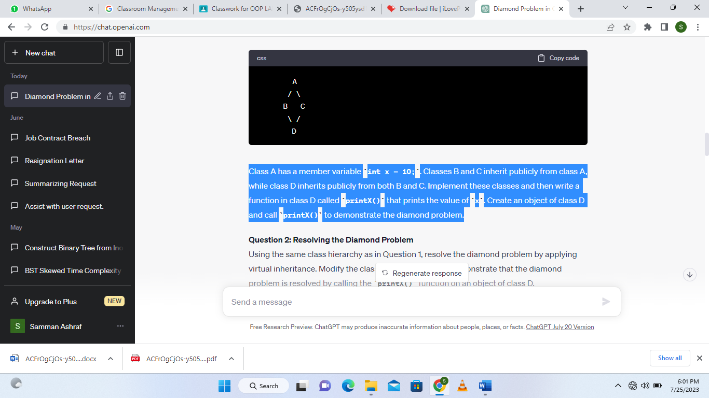
Class A has a member variable int x = 10;. Classes B and C inherit publicly from class A, while class D inherits publicly from both B and C. Implement these classes and then write a function in class D called printX() that prints the value of x. Create an object of class D and call printX() to demonstrate the diamond problem. Build the code and check do you get any errors?

Exercise 2:

Using the same class hierarchy as in Exercise 1, resolve the diamond problem by applying virtual inheritance. Modify the classes accordingly and demonstrate that the diamond problem is resolved by calling the printX() function on an object of class D. Write your output here.

*********************************************

